Astronomy and Australian indigenous people

Research and written by Adele Pring, Department for Education and Child Development, in consultation with Aboriginal informants and teachers with a passion for astronomy.

Why teach about Astronomy and Australian Indigenous people?

Knowledge of the sky world from Australian Indigenous perspectives is useful for the following reasons:

• finding directions: a survival strategy if lost

• telling the time at night without a clock

• a weather forecaster

• hearing and reading fascinating creation stories

• placing relevant Australian meanings on the southern hemisphere sky

• a calendar for the changing seasons

• learning about Aboriginal law

• learning about the diversity of Indigenous peoples in Australia

background information
Aboriginal and Torres Strait Islander peoples, have many stories about the night sky, the moon and sun. Their ancestors have observed the night sky for more than 40,000 years and many of their traditional stories tell of events, eg eruption of volcanoes, dated to thousands of years ago.

Different colours and intensities are observed as well as seasonal and nightly movement in the night skies. It was known that planets had separate orbits.

Aboriginal and Torres Strait Islander people applied knowledge of particular stars and constellations for many purposes including:
• a calendar for the changing seasons indicating changes in weather, availability of particular foods and time for particular ceremonies

• a survival strategy if lost by being able to tell the time, predict weather and find directions at night, a sensible time for travelling if living in a hot, dry desert area or in cold areas if there was no access to fire

• hearing and reading fascinating stories which explain the creation of the earth and sky worlds through the actions of spirit ancestors which remain in the environment

• learning about Aboriginal law: reinforcing the teaching of law including how to behave and punishments for breaking laws by referring to spirit ancestors in the sky world (not so different to Christianity and other religions)

• placing relevant Australian meanings on the southern hemisphere sky as opposed to constellation stories from the northern hemisphere which in Australia appear upside down

Examples of each of the above are included in the following pages.
Diversity within indigenous Australia

It is estimated that around 1788 when the British colonised the east coast of Australia, there were between 300-600 different Aboriginal and Torres Strait Islander language or dialect speaking groups, with a total population between 300,000 to 1,000,000 or more. Each group had their own land, sites and stories, though some stories were shared and some land boundaries overlapped.

The information in this document represents information from several Indigenous Australian groups and this is only a fraction of the whole.

Aboriginal people and Dreaming stories

Each Aboriginal group has their own spiritual beliefs, laws and explanations for how their environment was created and these were passed down through storytelling and ceremony in what is generally referred to in English as the Dreaming.

Torres Strait Islander peoples are related culturally to those of Melanesia in New Guinea. Their islands are between Cape York in north Queensland and New Guinea. Their stories, which they call legends, traditionally divide ownership of particular lands, seas and winds as well as sections of the sky amongst various clans.

People within each group are custodians of particular stories which are associated with particular sites. Some stories are men's only, some are women's only and some are public, ie for everybody.

Some stories cross Australia and are like maps for traditional trade routes crossing from Spencer Gulf in South Australia to the Gulf of Carpentaria and from Broome in Western Australia to Eucla on the coast of South Australia. Many stories are linked with the night sky.

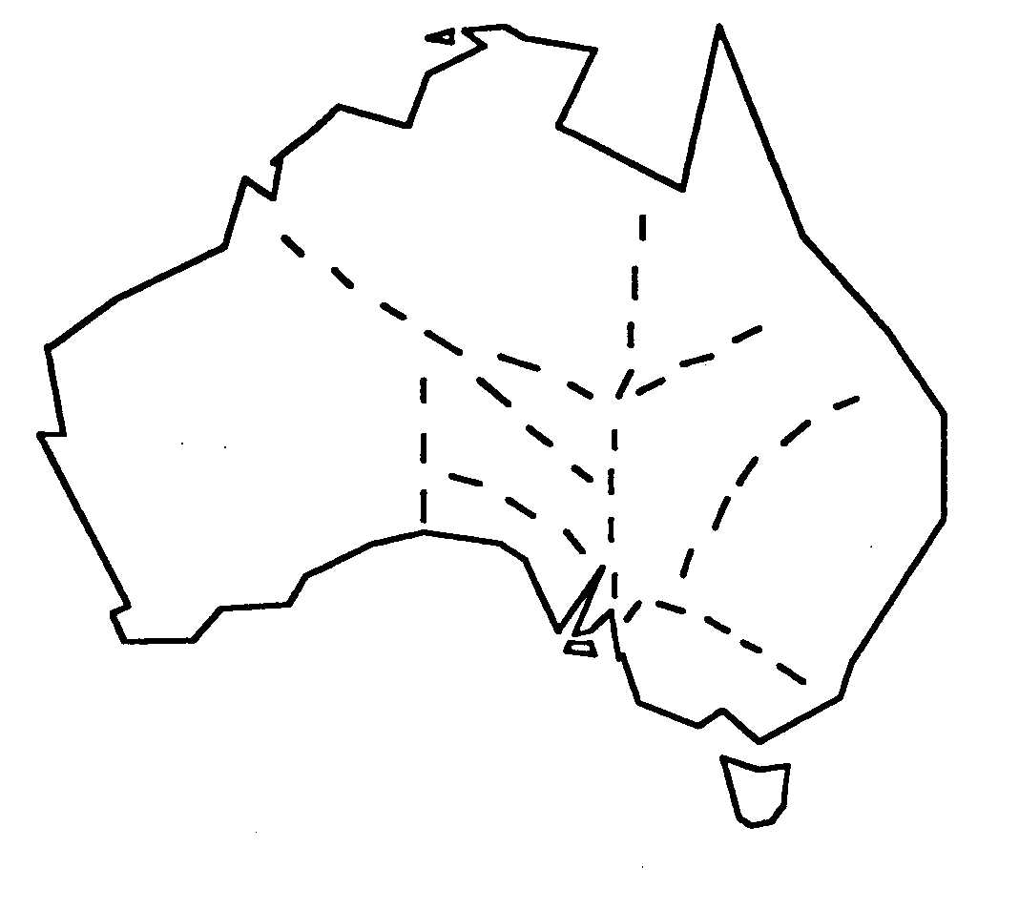
Trade routes followed Dreaming paths across Australia. Items highly valued for trade throughout Australia included micaceous red ochre from the Flinders Ranges; pitjuri, bush tobacco, high in nicotine, from south west Queensland; stone axes from volcanic rock in Victoria; pearl shells from Broome; and wooden artefacts.

Do Aboriginal people have better vision of the night sky or are there other explanations?

Dame Mary Gilmour, a non-indigenous Australian born in the mid 19th century wrote about how Aboriginal children she knew in New South Wales counted stars as a pastime by using groups.

She also said Aboriginal stockmen counted by threes, fours and fives and were faster and more accurate in counting cattle than non-Aboriginal stockmen because of the skill learnt from counting stars.

Further, Aboriginal people were very familiar with the changing night sky, knowing that planets came and went differently to other constellations and their ability to see faint stars was far greater than non-Aboriginal people she knew.

Fred Hollows said that Aboriginal peoples’ vision is much sharper than other Australians and that there are physiological reasons for this.

Questions for teachers

What do you think? Could it be that Aboriginal people have better vision? Could people train their vision of the night sky to be better?

Scientific understanding of the universe is constantly expanding but does the average citizen of the world now know more or less about the night sky than people in the past?

Pronouncing Aboriginal words
Aboriginal languages have been written using a range of orthographies. The best way to learn to say words from a different language is to listen to and copy a speaker of that language, however, the following rules can be generally applied to many Aboriginal languages (though there will be many exceptions). Place the emphasis on the first syllable of each word.

Most Aboriginal languages have more than one r sound. One is similar to the English sound in weary (retroflex r). A second is the rolled r used in the Scottish language. Another is a sound that is a mixture of r and d.

Vowels
a as in but
e as in pet
i as in pin (in the middle of a word)
i as in happy (at the end of a word)
o as in pot
u as in push

Consonants
tj is a sound similar to ch
th, dh are like English without the puff of air
p, b these sounds vary between the English p and b without a puff of air
t, d these sounds vary between the English t and d without a puff of air
ng is the sound in sing
ly is the sound in William
ny is the sound in news
Before you start
Access to the following resources will assist:
• star charts for each student or pair of students
• at least one globe
• a torch
• red cellophane (to cover torch)
• cardboard, broomsticks, gaffer tape
• overhead transparency projector
• overhead transparencies of Orion, the saucepan, Southern Cross and Pointers, Magellanic Clouds, Milky Way in winter, Pleiades
• arrange with the teacher librarian for access to any resources which the school might have which are listed in the reference list at the end of this document
• order a copy of the video Inside story: The Human race, ABC TV 27/5/97 57mins.
• order a copy of the video Bobtales: an animated series of 13 5 minute Aboriginal Dreamtime stories for young children, Film Australia, 13 x 5 mins 1977, also available from DECS Tape Services (see above)

Organise an astronomy night at the school (or on camp) when binoculars and telescopes are available. An evening when the moon is very new (or no moon) is preferable. Arrange , if possible, for an Aboriginal guest speaker who is confident to share knowledge of the night sky.

The orbits of planets and their moons can be role played by students on the school oval with the sun in the centre, planets is order and moons orbiting their respective planets and comets (represented by the most energetic students) orbiting across all.

If all the planets start in a straight line from the sun it won't be long before they're not, which is a good way to show how they are in reality, ie hardly ever lined up straight.

Jointly plan with schools in the region to have a visit from the Stardome, available from The Investigator Science and Technology Centre. The Stardome enables participants to view a virtual night sky albeit minus planets, moon, Milky Way and Magellanic Clouds. It allows an excellent opportunity to observe the changes in the night sky daily and over the seasons and prepares students will for looking at the actual night sky.
Find out what students already know and think about the night sky

Find out from students which constellations or other features of the night sky they know. Once you have this knowledge you can build on what most students know and value the knowledge of those who already know more.

Most students will know the 'saucepan' and the 'Southern Cross' and some will know the Milky Way and will have watched satellites moving differently to stars in the sky. Relatively few students will know more unless they have studied this topic before.

Nearly all students will know their star sign but hardly any will know how to find it in the night sky. They may however be keen to find it once they start learning more.

See more notes about suggestions for teaching activities at the end of this booklet.

Student survey

Complete the following survey form. Your work will not be graded according to the accuracy of answers.

Draw or explain in words the following:

• where the sun rises and where it sets
• whether this changes through the year and if so how
• the path of the moon through the sky
• what phase the moon is in
• where to find the Southern Cross and what it looks like
• how the Southern Cross can be used to show the south direction
• where and when to find the 'saucepan' and what it looks like
• where and when to find Pleiades and what it looks like
• what colour Mars is
• where the Magellanic clouds are and what they look like
• where the Milky Way is and what it looks like
• how you learnt what you know

Write down why you think some people know more than others.

How long you need to be away from unnatural light to have your best night vision?

Most Indigenous Australian children today live in houses and go to school whereas last century most lived much of their time outside. How might this affect their vision and knowledge of the night sky?

Where do the names Orion, Moon, Southern Cross, Pleiades, Mars, Magellanic Clouds and the Milky Way come from?

The Sun
There are many Aboriginal stories about the sun. One story is that the Sun woman carries her firestick across the sky each day and sets up camp each evening.

The Boorong of north west Victoria believe the Pupperrimbul, the little bird with the red patch above the tail (probably one of two varieties of firetail finch), made Gnowee, the Sun, by throwing a prepared emu egg into space. Before this the earth was in darkness. Others say that the egg was prepared by Berm-berm-gle, two large stars in Centaurus who represent brothers and the egg was carried into space by Penmen, a different small bird.

If the Pupperrimbul were to be killed there would be a fearful fall of rain. The Pupperrimbul and other creatures are spiritual representations on earth of old spirits.

Using a model to learn about seasonal changes in the path of the sun

Have students stand and face north and raise their west hand. They may need a while to work this out. Give them clues linked to local topography, eg the Mt Lofty Ranges are to your east and the coastline is to the west.

Students will probably copy a leader. If they are unsure, give them clues such as which side of the bus or car the sun shines through in the morning or afternoon to work out east or west.

Explain to students that an Aboriginal baby born in the middle of Australia until recently (and maybe even now) would learn these directions possibly before learning to talk and walk as a survival skill necessary in adulthood.

Make a large cardboard sun (approx. 45cm diameter) and attach it to a stick approx. 1.5m .

Students can volunteer or be asked to carry the 'sun' across the 'classroom' sky showing direction of apparent travel and to show the seasonal changes.

Start with the sun showing that it is almost overhead at midday in summer but closer to 45 degrees in mid-winter. In mid summer it rises well south of east and sets well south of west. In mid winter it rises north of east and sets north of west.

Use a globe and a torch, to represent the sun, to show how the sun rises south of east and sets south of west.

Stone arrangements or carvings for use as a calendar and compass

John Morieson is researching Aboriginal stone arrangement sites in Victoria and is finding that some indicate cardinal points as well as where the sun rises and sets at the equinox and solstices. His work is not complete and is as yet unpublished.

Student activity
A class could plan and possibly make a stone arrangement in the school grounds or engravings on stone or wood to show where the sun rises and sets at the solstices and equinoxes and to show the cardinal points.

Using the sketch following as a starting point, students could make predictions about where the sun might rise and set during the solstices and during equinoxes.
The appropriate dates could be written on to a class calendar so that observations could be made using relevant equipment, eg compasses and results could be checked with predictions. Models could be made to explain the relationships.

Stone, paving brick or painted signs could indicate the points.

Talk with students about how knowledge of the above could help with planning large gatherings of people for ceremonies.

Hypothesise about which direction the openings of traditional Aboriginal shelters might have been facing in particular seasons and why.

Traditional shelters built by Aboriginal people took advantage of the position of the sun as well as the prevailing wind. Talk to students about how architecture students have to take into account the position of the sun in the sky when designing energy efficient buildings in much the same way as traditional Aboriginal people.

Talk to students about the energy efficiency of placing the large windows of a house facing the north or south (which allows the light but not the heat of the midday sun in during summer and lets the heat in during winter), rather than east and west (which lets the hot morning and afternoon sun in during summer). Explain to students that builders still build energy inefficient houses with the large windows facing the street rather than facing north.

Students could make models to compare an energy efficient building today and a traditional wiltja of the past with an inefficient building today.

finding directions during the day and night

A survival skill
Larry Higgins, Aboriginal man from Port Lincoln says "When you go fishing, for your life and safety it’s important not only to learn to read maps and charts but also the stars. Before technology came along the old people learnt to navigate by the stars. If you’re not in sight of the land and you haven’t got access to satellite navigation (GPS Global Positioning System) or a compass, both of which can break down, you should make sure you can rely on finding directions from the stars.

I learnt it from Grandfather Hirschausen when I was a child. We grew up at the family farm at Poonindie just north of Port Lincoln. Later on I was working as a fisherman over our way around Port Lincoln and I would use my knowledge to line up the Southern Cross and Pointers to find south. You could also tell west from the evening star (Venus) because its the first star you see at night if its in the sky. If you saw it in the morning it would be in the east.

If I had the chance over again I’d listen to what my grandfather was trying to say to us in terms of safety at sea instead of just day dreaming and taking things for granted."

Finding directions during the day
Aboriginal people living in the (apparently) featureless desert landscape in parts of Central Australia were asked how they knew their way without compasses.

They were asked if it was the path of the sun, the night sky or something else and they replied that they just knew in their heads. When asked by a teacher what they did when they got lost they had trouble understanding the question but finally replied ‘We go home!’

Very young children in this area are trained to learn their people's names for cardinal points. Instances have been noted of toddlers, too young to speak, demonstrating their knowledge by looking in particular directions (to cardinal points) when instructed. There are of course different names for directions according to the different language groups.

A woman in a clinic is asked by the doctor which leg hurts as she replies "My 'west' leg". The use of cardinal points is practised continually in this way, reinforcing the knowledge. Compare this to 'left' and 'right'.

It is possible that knowledge of directions is learnt at such a young age that people cannot articulate how they know. In the daytime, it is quite likely a combination of knowledge factors including:
• path of the sun
• prevailing winds,
• features in the landscape such as hills
• changes to tracks by wind
• colour of bark of north of tree trunks compared to south
• position of flowers on a plant

In some areas, Aboriginal people were buried in positions facing east. In the Flinders Ranges, the Adnyamathanha people built a semi-circular wind break around the head (south) end of graves to provide protection from the south wind.

Student activity
Students could practice referring to cardinal points instead of left and right, for example, my east hand or my south west foot or the north whiteboard.

Observe nature in the school yard to try to work out signs for directions using some of the factors above.

Using the Milky Way, Southern Cross and other stars to find directions at night
Particular stars and constellations are linked to Dreaming stories which themselves are used for direction finding.

The video Inside story: the human race shows Jack, an Aboriginal man in his 70s in a 500 km walking race against younger men in northern WA. Jack chooses to walk at night with the stars as his guide. An excellent video to show Jack's cleverness and knowledge of his country and the night sky. His home country is near the Great Sandy Desert and the Bungle Bungles in the Kimberley region in northern Western Australia.

In very hot environments it makes sense to walk longer distances during the night rather than the day to prevent dehydration and exposure.

Barney Lindsay, a Ngarrindjeri man from the Riverland in South Australia says "In summer the Milky Way goes from this way (south) across here (to the north) but in winter its across the other way (east, west)."

Leroy Richards, an Adnyamathanha / Wailpi man from the Wilpena Pound area in the Flinders Ranges in South Australia says ‘When I was working as a stockman all around the north, Frome Downs, Innaminka, Gidgealpa, Balcanoona, we would drive the cattle or sheep at night when it was hot. This is called moonlighting the stock. The non-Aboriginal stockmen would say “We have to head off this way”. I’d say “You go that way if you want but I’m going this way”. I would go and soon I’d hear them following. I never once got lost. We grew up knowing the country and the sky. I’m forgetting now I sleep under a roof.”’

Using the Southern Cross for telling the time

Evelyn Crawford used the Southern Cross for telling the time when working in cattle camps as a drover. ‘You’d say ...”Wake me up when the Cross turns over ... Wake me when the tail’s this way ... or that way ... or when the bright star’s over ‘ere...” and you’d draw it on the ground. You could tell every two hours by it.

We learnt to identify all the stars by their Aboriginal names. They had meaning for us, and there were stories about them all. I learnt the white man’s names later.’

Student activity
Make a model of the Southern Cross and Pointers to show how their position changes during the night as well as how they are low in the south sky during summer and high during winter.

Use a star chart to plot how you would see the Southern Cross and Pointers at two hour intervals on the night of your birthday. Indicate south on each drawing by use of lines and an S. Compare the angles to those on a clock.

*
*
*
*
*

*
*

Finding south from the Southern Cross
The Southern Cross can only be seen in the Southern hemisphere. It is quite close to the 'celestial pole', an imaginary point which extends from the Earth's 'pole'.

Students can work out where south is by drawing an imaginary line through the long axis of the Southern Cross and another from the mid point of the Pointers. Where the two lines intersect is the 'celestial south pole'. The celestial pole can also be located by the mid-point between the Cross and Achernar.

Read more in the section about the Southern Cross.

Ancient rock engravings - are they maps of stars?
Sydney, the largest city in Australia, was once home to many groups of Aboriginal people including the Dharug (Daruk), Awabagal, Eora and Tharawal.

Dr. David Branagan of Sydney University’s Department of Geology and Geophysics believes that ‘Aboriginal rock engravings might be ancient star maps and that patterns of holes in rock platforms appeared to be maps of constellations including the Southern Cross and Orion.’ ‘The one-centimeter holes appear in platforms of sandstone in the Ku-ring-gai National Park, north of Sydney, and along the Hawkesbury River, on the NSW central coast.’ ... There was even evidence that some of the carvings were maps of the lunar cycle.’

Fraser Farrell of the South Australian Astronomical Society says that he has seen a rock engraving in the Gibson Desert recording a super nova seen centuries ago. Its location in the engraving is as recorded also by Chinese.

The Southern Cross

The Southern Cross was named by Europeans who sailed and 'explored' parts of the southern hemisphere. This constellation already had many far older names.
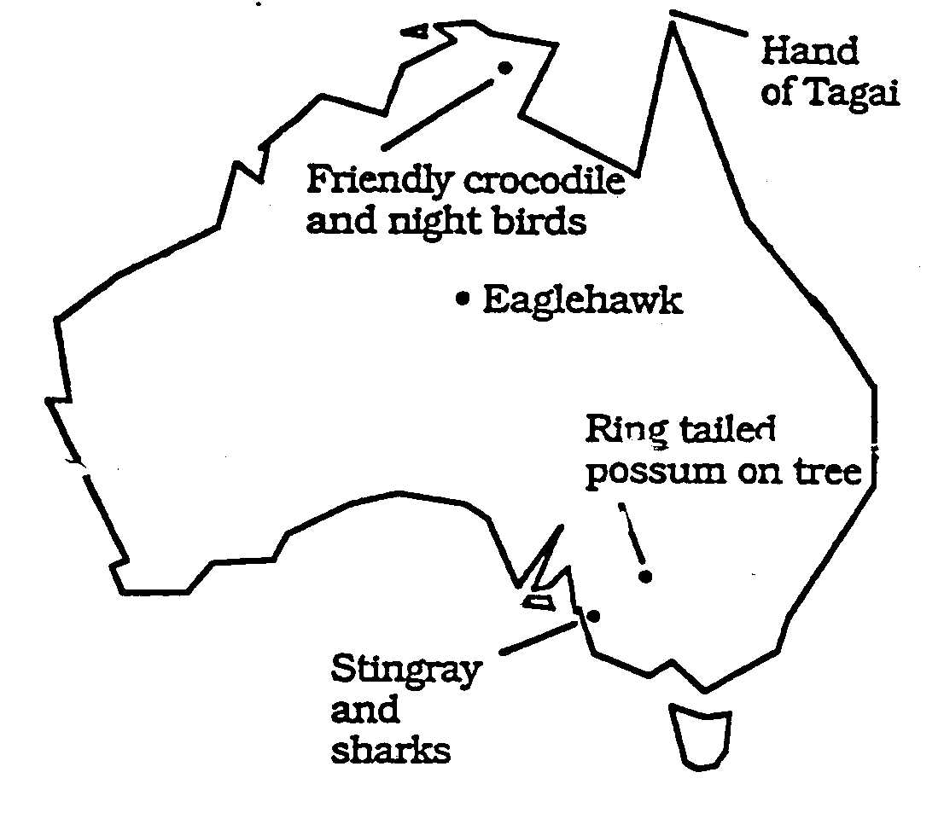

The Southern Cross and Pointers as a stingray and sharks

To the Ngarrindjeri people, the dark shape of `the Southern Cross is the stingray Nunganari and the Pointers are sharks Ngarakani. Perhaps only the fins can be seen. The sharks are a ngatji (or totem) of Ramindjeri people of King's Point near Encounter Bay in South Australia and are not hunted by them. If the shark killed a person it could not be prevented.

The Southern Cross and Pointers as a friendly crocodile and night birds
Narritjan Maymura from Marlindi in Arnhem Land told the story of the Milky Way to Ted Egan of how the Southern Cross is a friendly crocodile, the Pointers represent night birds and the Milky Way is a river. When people and animals died their spirits became new stars in the Milky Way.

The Southern Cross as an Eaglehawk
In the Kimberley and in parts of Central Australia, the Southern Cross represents the wedge-tailed eagle.

The Southern cross as an Emu
Milly Taylor who has Yankunytjatjara and Luritja ancestry says the Southern Cross is the emu's footprint.

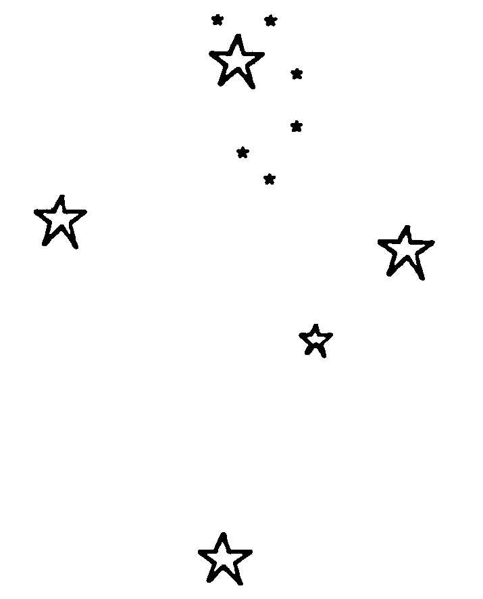
The ring tailed possum on the Southern Cross

The Boorong people of north western Victoria see a ring-tailed possum they call Bunya at the top of the tree forming the Southern Cross. The two smaller stars above the top star represent its ears or eyes and its tail changes position as the cross moves.

The Southern Cross as Tagai's hand
The Tagai constellation shows Tagai standing in his canoe. His left hand, the Southern Cross, holds a fish spear. The stars of Tagai guide voyaging and cultivating in the Torres Strait Islands.

Student activity
Using an atlas, hypothesise and analyse possible reasons why the above mentioned indigenous groups would view the Southern Cross differently.

List positive reasons why Australians should learn about the night sky from perspectives of Australian indigenous peoples.

Nightly and seasonal change observations of the Arrernte

Arrernte people noted such attributes as the motion and degree of magnitude of stars. Like other Aboriginal groups, they differentiated between the nightly movement from east to west similar to that of the sun in the day and the gradual annual shift of the constellations in the same direction.

'As an illustration of these apparent stellar motions the Southern Cross constellation Iritjinga was taken, and its positions in the colder months of the year and later in the evening were correctly described.

To foretell accurately the position of a constellation through the night and throughout the year requires a good knowledge of stellar topography and movement, and serves to show their keen powers of observation'.

They also noticed ‘that certain stars lying to the south are always visible at night, although their position in the sky alters with the seasons. For instance, the writer was told that Iritjinga and the Pointers were always to be seen, although they were sometimes high up in the sky and sometimes low down.

Venus as Morning Star and Evening Star

Did Adnyamathanha people know that the earth was round?

Buck McKenzie, an Adnyamathanha man from the Flinders Ranges in South Australia suggests that perhaps his people knew about the earth being round.

The Adnyamathanha are from the northern Flinders Ranges in South Australia. Their story of Warta Vurdli the Morning Star tells of Warta's two disobedient sons and their mates who continually broke taboos by eating the parts of the kangaroo which should be reserved for the older people by law.

Warta created large groups of red and blue kangaroos from a small one his sons had given him then told his sons and their disobedient mates to hunt them. As they did so he caused all of them and their throwing sticks to float into the sky and turn into blue and red stars.

Quietly standing near he twisted his spear shaft in the ground making a hole into which he dropped to become the Morning Star (Venus) so that he would be away from his sons. Even today the Morning Star rises when the other stars are setting and vice versa.

Student activity
Make a list of what can be learnt from the story above about the earth and sky environments including fauna and what can be learnt about Aboriginal laws.

Talk about Aboriginal punishments affecting not only the people breaking laws but people close to them. Talk about the concept of shame and similarities in laws of other cultures.

Jimmy James' story of the Morning Star

Jimmy James was a famous tracker in South Australia who worked with police for many years in the Riverland. Jimmy grew up at Ooldea in the west of the state. One time when camping out with school students he told the story of a young couple travelling with a male relative. Every night the couple waited until they thought the male relative was asleep so they could be passionate with each other.

Every time they started the relative would wake and say 'Hey, what are you doing there?' because they were not supposed to be together in this way. After many nights travelling and the same thing happening each night, they decided to trick the relative and made him climb a tall tree. When he'd climbed to the top they cut it down and left him in the sky.

Unfortunately for them, the relative now appeared as the Morning Star so he is still there in the sky watching everything and reminding them to behave themselves.

Student activity
Discuss as a class ways in which different cultures attempt to control behaviour such as that described above. Discuss the differences between what is illegal, immoral and unethical.

Student activity
Working scientifically, find out how the Morning Star and the Evening star can be the same’ star’.

One method to try this is to have a person representing the sun (with a torch), another the Earth and another Venus. When Venus moves behind the sun, it cannot be seen from earth, nor can it be seen when it is directly between the sun and Earth.

To the Boorong, Venus is Chargee Gnowee, sister of the sun and wife of Ginabongbearp, the planet Jupiter.

Orion and the saucepan

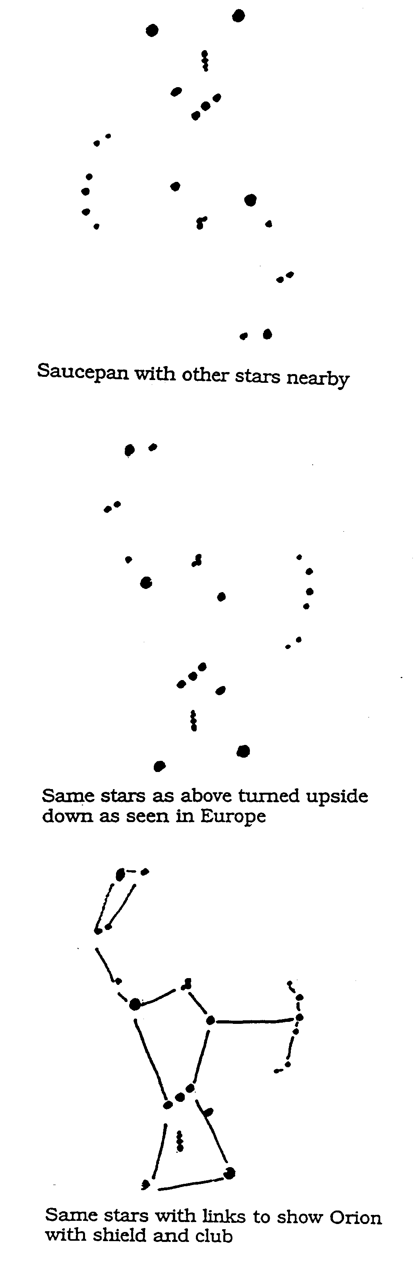
Apart from the Southern Cross, the most widely known constellation amongst Australians is the 'saucepan'. It is obvious when viewing this constellation in the southern hemisphere why it is called the saucepan.

In many Aboriginal stories, this constellation is sometimes seen as a hunter following the young women in the constellation known in Greek mythology as Pleiades.

In Greece in the northern hemisphere this constellation is part of Orion, the hunter with club and shield who is also following Pleiades. To see Orion with club and shield it is best to view the saucepan upside down or make overhead transparencies of the images on this page.

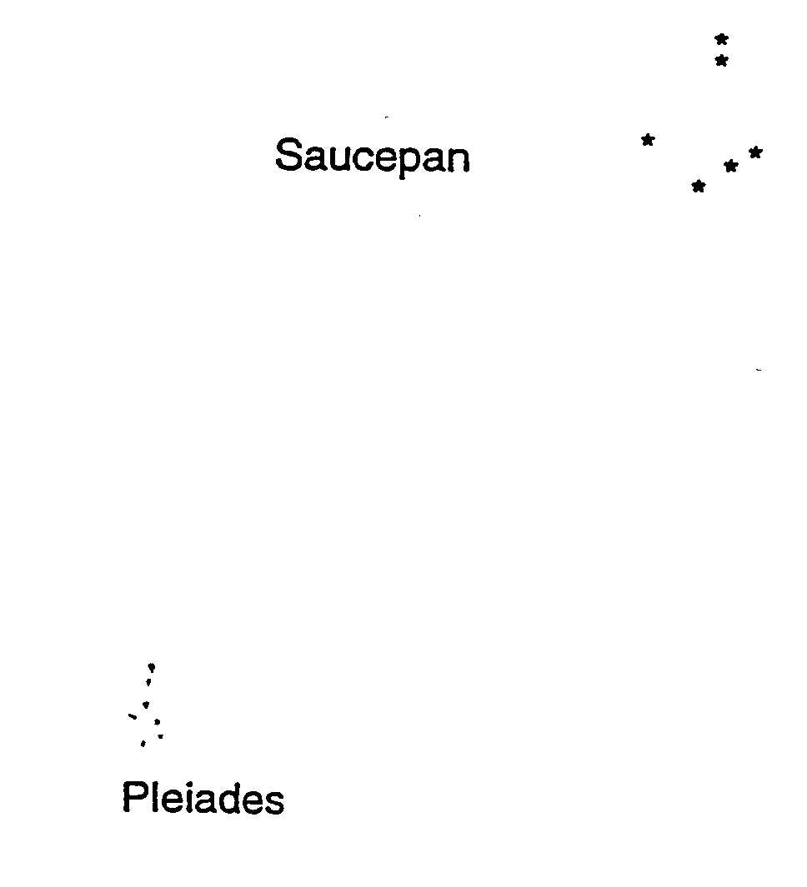

The Pleiades in the ancient Greek story. The young hunter Orion scoured the forest
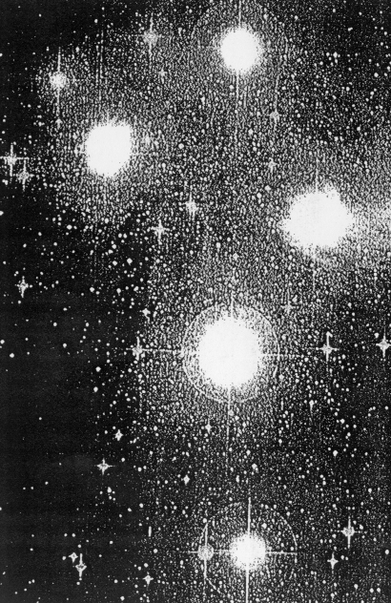
SEVEN SISTERS (PLEIADES) STORIES

Throughout the world there are many stories about young women who are sisters based on the Pleiades cluster of stars. The Pleiades are 400 light years from earth in the constellation Taurus.

See the diagram of the saucepan on previous page to see the relative position of Pleiades.

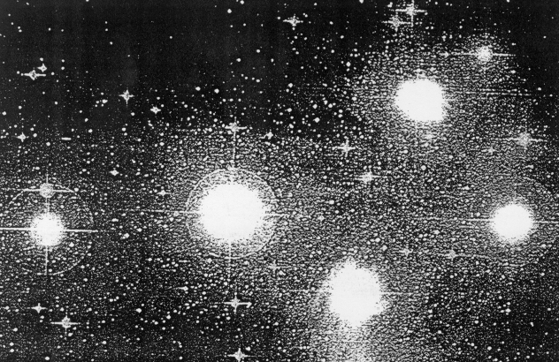
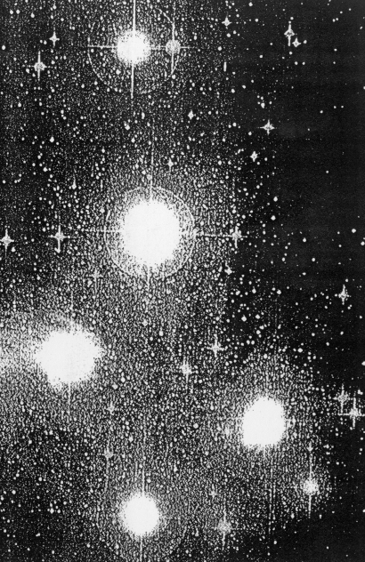

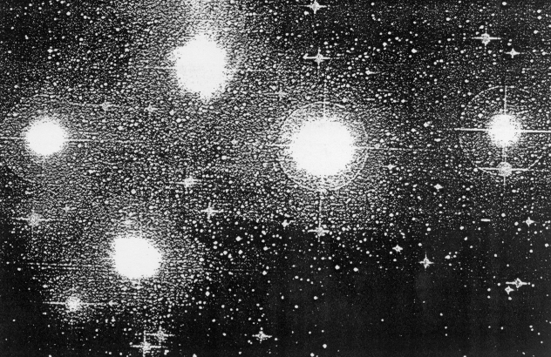
Pleiades as seen in the northern hemisphere when high in the sky.

Pleiades as seen in the southern hemisphere summer sky

Pleiades in the east spring sky in the southern hemisphere

Pleiades in the west autumn sky in the southern hemisphere
The Pleiades in the ancient Greek story. The young hunter Orion scoured the forest with his faithful dog Sirius at his heels. One day in the shade of the forest he met a group of Diana's nymphs, the seven Pleiades, daughters of Atlas. 'These fair maidens needed but to be seen to be passionately loved, and Orion's heart burned as he sought to approach them; but they were very coy, and, as he drew near and addressed them, turned and fled.'

He followed but they sped on until their strength failed. They called upon Diana for help and just as Orion approached, panting and weary he saw seven snow-white pigeons fly into the sky. There, they changed into a constellation of seven bright stars and shone for ages. When Troy fell into the enemy's hands they grew pale and one withdrew to hide her anguish from the curious eyes of men.

Diana was later tricked by Apollo to unknowingly kill Orion and when she realised she placed him and his dog in the sky. Diana herself travelled with the moon at night and visited the earth by day with her nymphs.

The Pleiades in other countries.

Maori people of New Zealand have a Sisters story based on the Pleiades. They call the constellation Matariki.

Indigenous peoples in North America ‘as far apart as the Huron-Wyandots of eastern Canada and the Nez Perces of the north western United States also related myths about the seven sisters in the sky.’

The Huron-Wyandot version describes the sisters visiting earth during the day and rising to the night sky in the evenings.

In Japan the constellation is Subaru, hence the symbol on Subaru motor vehicles.

The Pleiades in Indigenous Australian stories. There are many ‘Sisters’ stories in Aboriginal Australia linked to the Pleiades group of stars. In all the indigenous Australian stories about the sisters, they spend much of their time running away from unwanted and unlawful approaches of a man usually Orion, Venus or the Moon, depending where the story is told. Some aspects of the stories are secret but other aspects can be known about.

In one story from New South Wales the sisters are called 'Mayi-mayi and are chased by Wurunna who succeeds in catching two of them by a trick and making them his wives, until they escape into the sky.

In eastern Arnhem Land, Pingal the moon lusts after the sisters and pursues them, but they manage to climb up to the sky, where they still flee from the moon.

In the Kimberley, the Seven Sisters are chased by the eagle hawk, the Southern Cross, and in a Dieri story from Lake Eyre, the ancestor figure who tried to capture one of them was prevented by a great flood.’

The story of Kungkaralkalpa (Sisters) belongs to several groups throughout Central and Southern Australia including the Pitjantjatjara and Yankunytjatjara. The story involves features of the landscape such as caves and hills where the sisters travelled while they were on the earth and the night sky where they rose to try to escape from Wati Nyiru.

In the Parnkarla version from Eyre Peninsula in South Australia, the girls are called Pallarri and the man was Bira, an old man from the moon. To the Nukunu the sisters are Purlara chased by three brothers.
To the Narangga of Yorke Pensula the sisters are Mangga Manggaridi.

In one Ngarrindjeri story, the Pleiades are Yatuka, six girls and one boy while Ngalwara, a nearby constellation represents six young men. The Tangane of the Coorong called the boys the Ngawiri. When the full moon chases the girls, they hide and cannot be seen in the sky. In another Ngarrindjeri story, the Pleiades are mallee fowl eggs.

To the Boorong, the Pleiades are young women Larnankurrk playing to Kulkunbulla, young men dancing represented by the stars in the belt and scabbard or Orion. Gellarlec, an old man singing and beating time for the dancing, is represented by the bright red star Aldebaran in Taurus.Aldebaran is between Orion and Pleiades. Gellarlec is also a rose coloured cockatoo, probably the Major Mitchell cockatoo.

Student activity
Discuss possible reasons why the Pleiades represents young women in many cultures around the world. One suggestion is that they are ‘soft and feminine’ and secluded from other bold stars. Another is that they look cdifferent from other constellations and are always followed by Orion the hunter. Both are constellations which can be seen, at least seasonally, from most countries around the world.

Pleiades is sometimes hard to see from the metropolitan area because the stars are quite faint as well as being low in the northern sky in the evenings in the warmer months and not visible during the cooler months except early in the morning for a few months. It is easier to view them if you focus your vision at a point near them rather than directly at them. Use overhead transparencies to compare the way in which Pleiades and Orion are viewed in Australia in comparison with the northern hemisphere.

The Pleiades and the change of seasons.

The Pleiades are not visible in Australia all year. They can be seen in the summer sky not far above the horizon and they briefly appear again in mid-winter just before sunrise. The stories show that indigenous Australians knew of their changing positions during the year as well as during the night.

They linked the appearance of Pleiades in the sky with seasonal changes of foods, weather and ceremonial life.

Artunyi (Pleiades) in the Flinders Ranges, South Australia - an Adnyamathanha story

The Adnyamathanha explain that the Artunyi always travel across the sky near the horizon to avoid a sacred men's site in the middle of the sky. They are visible for all of the summer but in winter you can only see them in July before daybreak indicating the time for the boys to begin becoming men. Their presence in mid summer indicates the time for hunting carpet snake for food.

Artunyi in winter indicate the beginning of frost time when Adnyamathanha children would rise early, make a fire, run around dodging sunbeams (which would stop them growing), collect ice and frost to eat and to rub over themselves so the girls would grow large breasts and the boys would grow long beards.

Gambu Gambu (Pleiades) in central New South Wales - a Muruwari story

‘Gambu Gambu being shy young women could only be seen by people with particularly good eyesight because they were always trying to hide. During mid-winter they rose about three hours before the sun and it was believed that they urinated on the ground when in that position. Their urine (gua) wet the ground but they were so pure this moisture turned into frost or ice by sunrise.

Jimmie Barker said that when he was a child he always put a dish of water outside on winter nights. He liked eating the ice and was never deterred when his mother, who was a Muruwari, said, “my boy, you eating Gambu Gambu gua:”’

Pleiades in the mid-north coast of New South Wales - a Ngemba story

‘When the Pleiades were seen in winter at about three or four o’clock in the morning, the old men always awoke. They filled their bark shovels with red-hot coals from the camp-fires and hurled them high into the air as the stars rose. This was to prevent the spirit-women, (Pleiades) from making the early morning too cold. If this was not done frost and ice were expected to cover the ground at sunrise’.

Pleiades in the north coast of New South Wales - a Bandjalang story
The sisters bring pleasant, warm weather before disappearing to the west for a while then make winter reappearance as a warning to select wives according to the law. Karambal, fell in love with Wareenggary, a sister, but was forbidden to marry her because they were not in the correct marriage groups.

The other sisters punished Karambal by bringing frosty weather which caused him to release Wareenggary. He later eloped with a young woman in the correct group but she was married to a great warrior who punished Karambal by burning down the tree he had climbed to escape, leaving him in the sky as the red glowing star Aldebaran (Alpha Tauri).

Student activity
Discuss possible reasons why some of the stories might have similarities and what this tells about the particular environments. For example which environments are subject to frost and which are not and why is this?

Talk about natural indicators you notice which signal the changing seasons.

Pleiades stories in Indigenous Australia which do not represent sisters
Pleiades and the saucepan as a fishermen in a canoe and fish
‘In the early times there were three very good hunters, Birubiru, Jandirngala and Nuruwulping and in the Dry Season they spent many days fishing from their canoe called Julpan. Every day they only managed to catch kingfish, and as all three of them belonged to the kingfish totem, it was forbidden for them to eat this fish.

At last they became angry with the fish that kept getting caught, and were anxious because they had no food to take home to their children. One of the men said, ‘I am going to take home any fish I catch from now on whether they are my relations or not. No one should go hungry when there is food to be taken. That is what I think.’ The others agreed, and they pulled in three more kingfish.

The sun saw what they were doing and called up a great storm to stop the men from breaking the Law. The clouds and sea and wind combined to make a great waterspout over the canoe. The nose of Julpan, the canoe, turned upwards, and flew round and round and up and up within the spinning column of water, with the three men still holding their fishing lines.

They went right up to the sky, Julpan the canoe, and the three friends, Birubiru, Jandirngala and Nuruwulping, forming the stars of Orion. The fish are the tiny stars below the canoe (the Pleiades), trailing still on the string lines.’

Usiam (Pleiades) - a Torres Strait Island story of hot weather arriving
The Tagai constellation shows Tagai standing in his canoe. His left hand, the Southern Cross, holds a fish spear. The stars of Tagai guide voyaging and cultivating in the Islands.

In ‘Naiger Kerker, later half of the north east season, Adud wer, a star which appears in the south-west, is mek for kipa gogob, the first rains.

Usiam, (Pleiades) rises in the east. Usiam is part of the constellation Tagai.’

Characteristics of this season include very hot weather with new plant growth and fruits. Turtles lay eggs and gardens are prepared, yams tubers are planted and banana suckers are transplanted. Bunches of bananas on the tree are wrapped up turning the skins red and changing the flavour. Fish traps are readied and fish hooks made from turtle-shell. Voyages are made and goods traded The approximate calendar months are from mid-October to early December. The season changes with winds from the west followed by lightning and thunderstorms.

Student activity
Students could research the regularity of ‘trade’ winds', where they occur and how these link with the seasons. The video Land bilong islander available from Tape Services, DETE, shows a little of daily life in the Torres Strait Islands.

Pleiades as mallee fowl eggs

Billy Poole, a Ngarrindjeri man from the Lake Albert area, said that the Pleiades constellation represented the eggs of the mallee fowl.

The male mallee fowl builds a huge nest measuring about three metres in diameter out of sand and decaying leaves. He then digs a hole in the centre for the hen to lay eggs. The eggs are covered and the heat from the decomposing vegetation incubates the eggs.

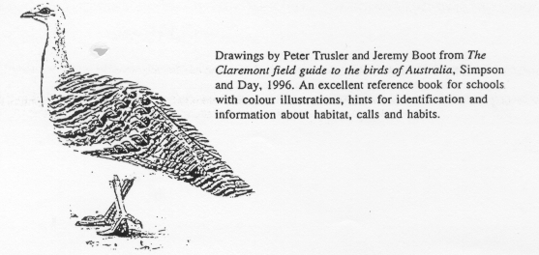
When looking at Pleiades, it is easy to see them as mallee fowl eggs and they look like a sparkling sandy collection in an otherwise dark part of the sky.

Pleiades as female parrots
In south western Victoria the Pleiades are seen as six female parrots.

Student activity
Use the Internet to view a photograph of Pleiades on the address www.aao.gov.au. One version is reproduced here in black and white.

Explain why the stories sometimes refer to seven sisters when there seem to be six only five bright stars and many less bright. View the Pleiades in the night sky and compare to a photograph.

More seasonal changes

Seasonal changes linked to the night sky on Groote Island and Yirrkala, NT, NW Victoria and western New South Wales

On Groote Eylandt, the appearance of two stars in Scorpio in the evening sky towards the end of April let these people know that the 'wet season' has ended and the dry south-easterly wind marimariga will begin to blow.

At nearby Yirrkala, the importance of Scorpio in the morning sky indicated the arrival of the Macassan fishermen in early December to trade. For thousands of years Macassans from Sulawesi visited Arnhem Land for beche-de-mer, the sea slug.

After harvesting and drying their catch, the Macassans left when the wind turned, taking them back to what is now Indonesia. They traded the beche-de-mer with the Chinese who considered it an aphrodisiac. The Australian government stopped the trade about a hundred years ago.

Mallee fowl season in north western Victoria

Neilloan, the mallee fowl of the Boorong people, is represented by the constellation Lyra. It is only visible for a few months a year in the north-west sky around April, about the time the birds on the ground start their preparations for mound building. At this time there are regularly meteor showers from the same direction which represents the male mallee fowl scratching leaves and sand to build the nest.

Mallee fowl eggs were not collected when Neilloan is in the sky. Nowadays they are not collected because the mallee fowl are an endangered species.

At the end of September, providing rains have fallen, egg production begins. Her disappearance from the sky was an indication that it was the time to look for the eggs.

The Tangane of the Coorong, one of the Ngarrindjeri groups, called Lyra Lawarikark, the mallee fowl.

Murray cod season in north western Victoria

The Murray cod is known as Otchocut by the Boorong people and is represented in the sky by the Delphinus (the dolphin) constellation. Gamma Delphinus is golden and yellow-white, the same colours as the flanks of the Murray cod.

The disappearance of the Otchocut constellation from the sky after September to October coincides with the end of the spawning season for the Murray cod.

See more about the Murray Cod in the section on The Moon.

Student activity
Both mallee fowl and Murray cod have become relatively endangered species in the last 50 years, rarely eaten by Aboriginal people because they want to protect them. Make a list of the factors which have contributed to their becoming endangered and strategies in place to help their survival.

Scorpio

Scorpio as hawks, a man and women

To the Boorong people of north west Victoria, the sting of Scorpio represents Karik Karik, a pair of hawks.

Another Boorong story is of Djuit, the bright star Antares in Scorpio who is the son of Marpeankurrk the discoverer of white ant larvae, a precious food. The stars on either side of Djuit are his wives.

Scorpio as crocodile
In one part of Arnhem Land, Scorpio represents Ingalpir, the crocodile. This is easy to see in the same shape as the scorpion.

For Maori people of New Zealand, Scorpio is the hook which pulled New Zealand out of the sea to become their land.

Arcturus

Arcturus is the woman Marpeankurrk the discoverer of bittur, white ant larvae, a staple diet for the Boorong between August and September, In late July, early August, Marpeankurrk appears in the north and when she reaches the west in about October, the season for this food is finished. Marpeankurrk is the mother of Djuit, the bright star Antares in Scorpio.

Canopus

To the Boorong, the bright star Canopus represents War, the crow. War was the first to bring fire to the Boorong. Nearby the less bright Carina is the female crow named Collowgullouric War. War is the brother of Warepil, the wedge-tail eagle. Their children surround them as small stars.

Sirius

To the Boorong, the bright star Sirius represents Warepil, the wedge-tail eagle. Nearby the bright star Rigel, is the female eagle.

Gemini

Castor and Pollux in the Gemini constellation represent Yurree and Wanjel to the Boorong, two young men who hunt Purra, the kangaroo.

Corona

To the Boorong, the Corona is a boomerang thrown by Totyarguil, himself represented by Aquilla and he is the son of Neilloan the mallee fowl represented by Lyra. Aquilla is killed by Bunyips. Totyarguil's mother-in-law is Yerrerdetkurrk represented by the bright star Achernar. A Nalwinkurrk, or mother-in-law does not allow her son-in-law to see her, a taboo which many other cultures envy.

To the Wiradjuri, the Corona Australis is Kukuburra, the laughing jackass or kookaburra.

PLANETS

Jupiter

To the Boorong, the planet Jupiter is Ginabongbearp, an elder of the spirit people Nurrumbunguttias and husband of Chargee Glowee, the planet Venus.

Mars

Mars, the red planet - a Ngarrindjeri story from South Australia.

The Jaralde clan of the Ngarrindjeri people said that the planet Mars is the initiate Waijungari who fled into the sky still covered in red ochre after sleeping with the two wives of Nepele which was against the law.

One law learnt from Sisters (Pleiades) stories and the Mars story above is that a man can have multiple wives who are sisters.

The Ngarrindjeri believed that Waijungari shone brighter red in the Spring which symbolised the time of various species reproducing themselves.

Student activity
Students could work scientifically to find out if the plant Mars does shine brighter in Spring and seek additional explanations for this.

Seeing stars in the daytime

Buck McKenzie, an Adnyamathanha man, learnt when he was younger about Widlya Vari in the northern Flinders Ranges, his home country, a place where stars can be seen during the daytime.

Widlya Vari is a chasm also now called Bunyip Chasm. Darkness is experienced at this place even at midday. Widlya means ‘night time’ and vari means ‘creek’.

It is said that stars can also be seen during the day from deep in a well or mine shaft.

The moon

The Moon is sometimes male and sometimes female, depending on stories of different Aboriginal groups.

How Moon was created - an Adnyamathanha story
An Adnyamathanha Dreaming story describes how the Moon was created by a greedy nephew who kept stealing his uncle’s food. Every time his uncle hunted a kangaroo he would bring it to the camp, prepare it and cook it in a ground oven with hot coals.

The nephew would steal the cooked kangaroo as his uncle slept. He was punished by his uncle who made him climb a tall tree which was then cut down, leaving his now very fat round nephew in the sky in the form of the moon.

In another version of the story published in Flinders Ranges Dreaming the greedy nephews send their uncle to stay in the sky so they can marry his wives.

The moon as the native cat
The Boorong people of north west Victoria saw Mityan, the Moon as representing the quoll or native cat which has full moon, half moon and crescent moon shapes on its fur coat. Mityan was beaten after trying to entice someone else's wife to run away with him and he has been wandering ever since. The quoll probably hunts at night most effectively on a full moon, just as other cats do.

The moon man who chases the young women
In several versions of the 'seven sisters' stories, they are chased by the Moon man (see Pleiades stories). When the moon is full, Pleiades are said to be hiding because they cannot be seen.

Predicting good weather. Full moon - ceremony time
Ceremonies involving large groups of people, storytelling, song and dance were often held at the time of the full moon. This would have the advantage of maximum night light available but also, some say, a higher chance of fine weather.

It would also provide a calendar date to help participants plan. Disputes would regularly be dealt with first and then the ceremony would begin and often continue all night.

People who observe weather patterns find that the night of the full moon is usually calm.

Weather prediction based on the moon in western New South Wales
Evelyn Crawford ‘... learnt to read the weather signs from the moon. A big ring around the moon meant a big rain, a little line was just a little bit. ... Sometimes the moon isn’t right in the middle of the ring, but to one side or the other. That means there’s wind coming. It takes a lot of explaining to understand it right. You gotta live a lot of years in the bush for that ...’

Link between the moon and tides
The Bardi people living at One Arm Point on the tip of the Dampier Peninsula north of Broome in the Kimberleys, Western Australia, use their extensive knowledge of the moon and tides to time activities such as the collection of valuable trochus shells and other fishing pursuits.

Spring tidal movement can be up to ten metres so it is extremely important to be aware of them. Older members of the community have talked about using the stars to navigate when travelling by boats made from mangrove trunks. The boats are made from two layers of mangrove trunks stuck together by pegs. Parts of the boats, at least, often sat below water.

Navigational expertise was used in concert with knowledge of the tides since tides moved so rapidly at times, there is no way they could be paddled against.

The community assume that everyone has (and only outsiders don't have) a mental map of the area they move in thus directions consist for example of two bends/ two hills away.
Murray River fishing and the moon
Barney Lindsay, a Ngarrindjeri man living in South Australia's Riverland says "We used to go fishing for Murray Cod on a full moon."

Fish often rise to the surface to feed during a full moon. At other times when groups of Aboriginal people fished on the River Murray, they would light fires on their canoes with sandalwood, a wood which provides a pleasant aroma, little smoke and a bright light which attracts the fish to the surface.

According to Berndt's Ngarrindjeri informants the best season to fish for cod was Spring to Autumn.

Student activity
Students could monitor the weather on the nights of the full moon to check if it is usually fine and calm and if so find out why it might be.

Student activity
Find out which cycle of the moon is taken into account by people wanting to catch particular fish.

Student activity
Make models using cardboard and a stick of the moon in its various phases.
Aurora
"The Aurora signified with the Wotjobaluk that, at some great distance, a number of (Aboriginal people) were being slaughtered, and that the Aurora colour is the blood rising up to the sky. When the Aurora was seen by the Kurnai, all in the camp …(shouted) 'Send it away; do not let it burn us up'. The Aurora is … Mungan's fire.

The Ngarigo had much the same idea of the Aurora as the Wotjo. They said that it was like blood, and told that a number of (Aboriginal people) had died somewhere. When a meteorite was seen to fall, they watched it, and listened for the explosion. It was believed that this betokened that the (Aboriginal people) at the place towards which its path was directed were gathering together for war. Their neighbours, the Walgal, thought that the Aurora showed that the (Aboriginal people) a long way off were fighting, and that a number of them had been killed.

Rainbow
"According to the Wotjobaluk, the rainbow causes a person's fingers to become crooked or contracted if he points to it with a straight finger. This would prevent him from using his hand for making the markings with which the 'possum rugs are ornamented. …"

The Bunya-Bunya people in Queensland are also very much afraid of the rainbow, which they call Thugine (large serpent).
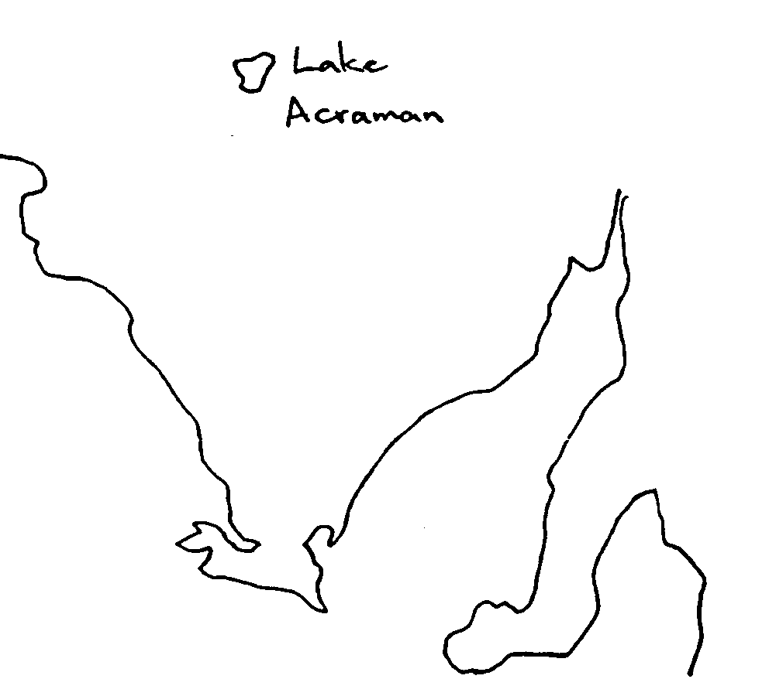
Meteors and comets
Lake Acraman in the Gawler Ranges in South Australia is a meteor crater. Students can study its huge relative size by using at atlas. It is no wonder that meteors caused fear.

A story about a meteor from the Burragorang/Illawarra region of the south coast of New South Wales

The story began on a very hot summer’s day as the sun was setting like a ‘red ball’. The sky moved, the moon rocked and stars tumbled and fell against each other. The Milky Way, the pukkan or path of departed spirits billowed and split, leaving blank spaces some call Magellanic Clouds. They formed traps for unworthy spirits and places for travelling back to earth in human form.

Star groups were scattered and some sped to the earth, red and glowing with a deafening roar, leaving molten pieces everywhere. People were too scared to move as the disturbance continued all night. In the morning they could see holes burnt in the earth and mounds and caves of molten pieces. The burning flames continued.

Comets and meteors were greatly feared. A comet in the sky 200 years ago coincided with the arrival of smallpox in South Australia resulting in hundreds of death amongst Aboriginal people.

"The Turrbal believed that a falling star was a Kundri (medicine-man) flying rhough the air and dropping his fire-stick to kell some one, and was sure if a sick man was in the camp he would die. Mr Petrie relates that once he was in a camp when a woman was sick and a meteorite was seen. Her friends at once began to mourn and cut themselves for her."

Meteors and Lyra

The Boorong of north west Victoria describe the meteors or shooting stars which seasonally come from the vicinity of Lyra, are the sand and leaves being raked by Neilloan, the mallee fowl as he builds his mound nest.

Student activity
Students can see a meteor crater in the video Inside story: the human race
which shows a walking race from a meteor crater in the Great Sandy Desert north 500 km to Wyndham through the Bungle Bungle Mountains in northern Western Australia.

It's a good video to show students the relative size of a meteor crater, the desert and the dramatic Bungle Bungle mountain environments. Students could talk about issues such as survival in the outback, new versus old technology and preparation needed for such adventures.

Magellanic Clouds

The Magellanic Clouds - an Adnyamathanha story

When missionaries told Adnyamathanha people that they should behave well because there was a fellow called God in the sky watching everything they did, their response was to say they knew, there were two and they could see you in the daytime too, even though you couldn’t see them except at night.

Adnyamathanha people are divided into two moieties or halves, Mathari and Ararru, also known as the north wind and south wind. They are also represented by two rocky peaks in the Flinders Ranges. They reinforce strict laws about marrying into the opposite moiety or skin group.

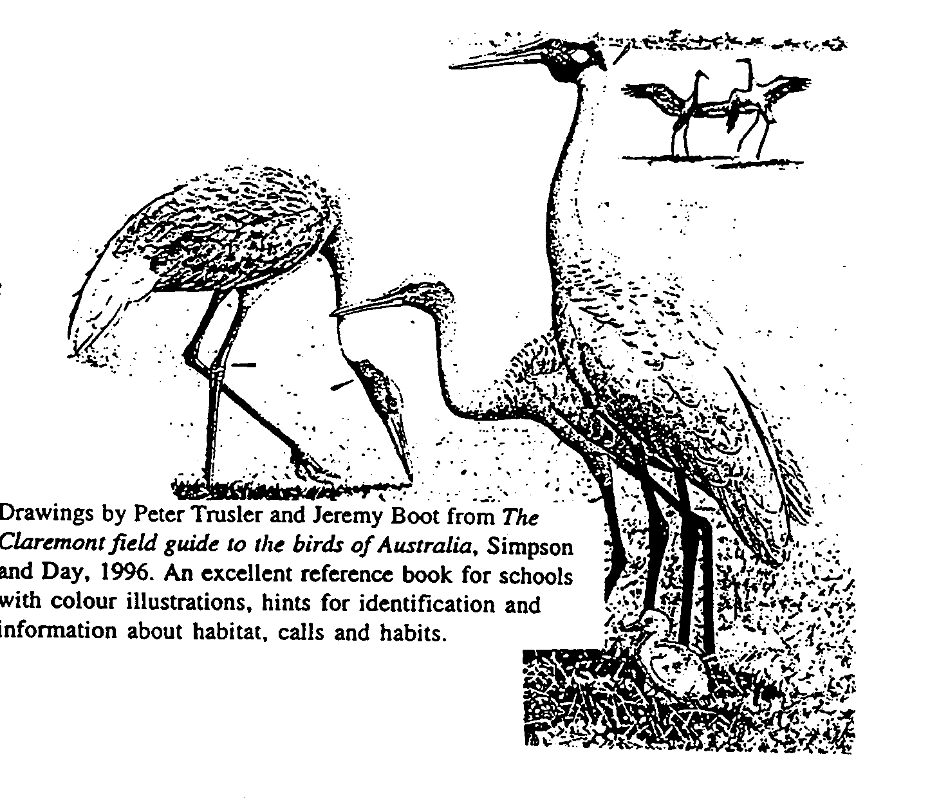
'The two that made that rule has gone up into the sky. You know the white spots you see in the sky, that's the two. They reckon that you can't do nothing in this land unless those two is watching. I remember the things we used to do. We used to get into a hell of a row over it because they reckon those two was watching us.

These Valnaapa (two people of the opposite moiety and the same generation) travelled widely throughout the Flinders Ranges throwing down rotting meat which had turned green thus creating copper deposits where it fell.

At Mt. Hack they made a fire out of porcupine grass, the sparks of which created gold and copper deposits, the ash creating lead and then said to each other ‘Let’s go up into the sky in the sparks of the fire. Let’s go up and stay there’.

They are called Vutha Warlka, the Large and Small Magellanic Clouds in the southern sky. They stay there watching to ensure that the marriage law is kept.

Magellanic Clouds as Brolga in the south east of South Australia
A story has been recorded from Albert Karloan, a Ngarrindjeri man about the emu and the ‘native companion’, otherwise known as the brolga, named after the sound it makes. In the story, the brolga flies into the sky after a fight with emu. The two Prolgi (Brolga) are represented by the Magellanic Clouds which can only be seen in the southern sky. The emu is also seen as dark patches in the Milky Way.

The brolga are considered non-migratory birds but do move long distances for food and water. According to Karloan, the large cloud is the male and the smaller, the female. The brolga live in wetlands.

Stories such as these can help scientists learn about species which are now rare or extinct in particular areas. Much of the south east of South Australia is now drained farmland but was once a huge area of wetlands.

The Magellanic Clouds also represent the brolga, Kourt-chin to the Boorong of north west Victoria.

Student activity
Discuss how the draining of the south east of South Australia have affected the presence of the brolga?

Magellanic Clouds as parakeet ashes
According to the Kaurna people of the Adelaide Plains, the Magellanic Clouds are parakeet ashes.

Kaurna cosmology

The Kaurna is the name now used to refer to the Aboriginal people whose land is now largely occupied by the city of Adelaide in South Australia and extending the Cape Jervis in the south, Crystal Brook in the north, the Gulf St. Vincent in the west and the Mt. Lofty Ranges in the east.

The term cosmology is used by Dr. Philip Clarke in preference to astronomy because the knowledge about the sky was an extension of the earth and 'underworld', the whole cosmos.

The night sky was like a mirror image of the earth with creeks, rivers and hunting grounds. There were widespread beliefs that ‘clever men’ or sorcerers/healers could visit this upper landscape and there acquire knowledge. In some regions novices would be ritually taken to this celestial region as part of their initiation. Many Aboriginal groups across Australia considered the Heavens or Sky-world to be where their spirit, or a part of it, travelled to after death.’

Kaurna believed that Monaincherloo, Munaintyerlo or Teendo Yerle, literally ‘Sun-father’ was the ‘highest creature’, the creator of all things in the visible world. Tindo was the sun and was female and Kakirra was the moon and male.

The Milky Way was called Wodliparri (hut river), a large river where a Yura or ‘monster’ lived in the dark patches. The Magellanic Clouds were known as Ngakallomurro, (‘parakeet ashes’).

The Pleiades were called Mankamankarrana, girls who gathered roots and other vegetables and Orion was Tinniinyarra or Kurku, a youth who hunted kangaroos, emus and other game on the celestial plain, called Womma.

The mother of the Tinniinyarra was a red star called Madletaltarni, probably Betelgeuse and their father was Parnakkoyerli, a seasonal star appearing in early autumn, indicating that large waterproof huts needed to be built for the coming winter.

Springtime (wiltutti) was under the influence of the constellation of the eagle Wilto and Summertime (woltatti), the wild turkey Walta. The star Parna signified autumn (parnatti).

According to the Kaurna the sky world could be entered from the east where the sun came from and the 'underworld' was entered from the west where the sun travelled at night after setting over the sea to return to the east.

There were several layers of Kaurna knowledge about the sky world, much of it limited to initiated men.

Student activity
Students could discuss how life may have been in Adelaide before books, television and computers and before any non-Aboriginal people arrived.

Students could describe their memories as very young children about the shape of the earth and the closeness or otherwise of the sky. What happened over the horizon or the edge of the world?

In many ways, the landscape and the night sky were like a book used to illustrate stories. For homework, students could sketch the night sky including the Milky Way.
Using stars to teach complex kinship systems

How the night sky reinforces complex Arrernte/Luritja kinship relationships and marriage rules

Arrernte people in Central Australia see the sky as divided into two great camps separated by the Milky Way, which is a river or creek. All stars to the east of this river are Arrernte camps, and all stars to the west are Luritja camps. The stars constituting the Milky Way are a mixture of Aranda and Luritja camps, containing many women. These east and west camps are further divided according to kinship groups which teach who can marry who. There are eight Arrernte skin groups.

Gamma and Delta Crucis together with Gamma and Delta Centauri are Iritjinga, the Eagle-hawk (parts of Southern Cross and Centauris).

The stars Alpha and Beta Crucis are the Luritja parents of the upper Pointer, Alpha Centauri.

Beta Crucis is the male belonging to the moiety group Knaria, and Alpha Crucis is his wife, who belongs to Ngala group. Their child, the upper Pointer, Alpha Centauri, is a Paltara boy.

These and other star names help in teaching about the complex marriage laws of the Arrernte.

It is not necessarily the brightness of a star that attracts attention to it, as some of second and third magnitude are ignored whilst much fainter stars in the immediate neighbourhood are not only named but given marriage classification as well.

Western Arrernte marriage rules:
Purula people have panangka spouses
kamara people have paltara spouses
bangata people have mbitjana spouses
knguarea people have ngala spouses

Children's moiety groups are as follows:
Children of purula men and panangka women are kamara;
children of kamara men and paltara women are purula;
children of panangka men and purula women are bangata;
children of bangata men and mbitjana women are panangka;
children of knguarea men and ngala women are paltara;
children of paltara men and kamara women are knguarea;
children of ngala men and knguarea women are mbitjana; and
children of mbitjana men and bangata women are ngala.

Student activity
Students could work scientifically or mathematically to design a diagram showing the relationships between the groups.

The book Tjarany - Roughtail: the Dreaming of the Roughtail Lizard and other stories told by the Kukatja includes diagrams to show the connections between kinship groups similar to the exercise suggested above.

The Milky Way
Emu hunting and nesting seasons
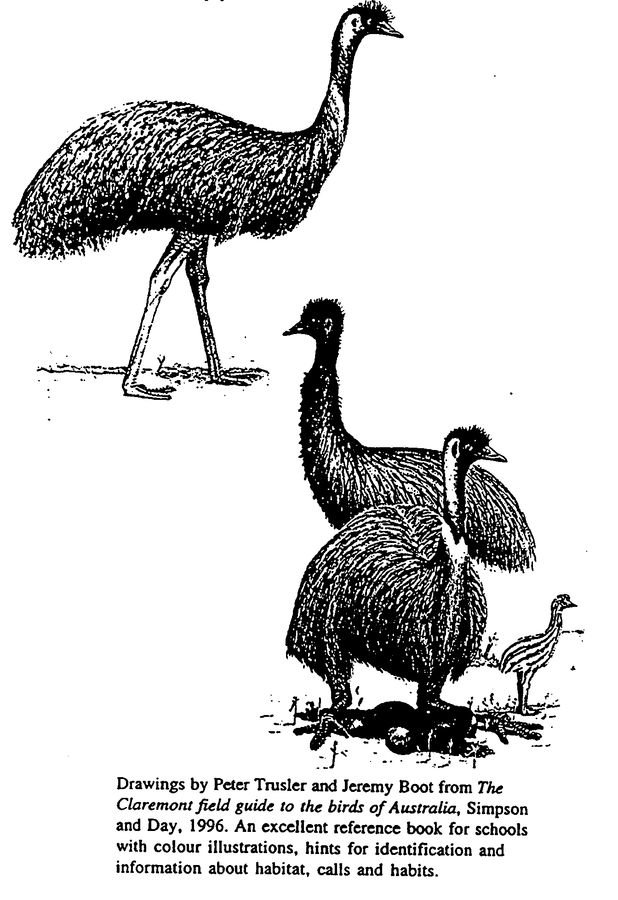
Western desert Aboriginal people and many others throughout Australia focus on the dark patches in the Milky Way in the cooler months and discern the outline of an emu with its head alongside the Southern Cross. At different times of the year, the night sky emu will be fully extended as though running and at other times appear to be sitting.

This corresponds in real life to the time when emus may be hunted or when they laying their eggs. Similar associations apply to other seasonal cycles, the life cycle of animals and the fruiting of plants though it must be noted that not all groups have access to the same knowledge.’

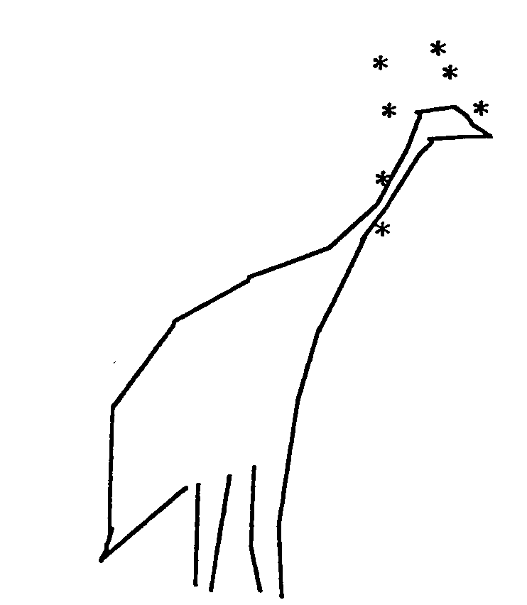
Evelyn Crawford says ‘... as we get closer towards the winter, there’s a black smudge shaped like an emu. Now when that emu is very distinct, the emus are laying eggs so that’s the time you go hunting’ for them.’
A rough sketch of the emu in the sky. The head is what is sometimes called 'the coal sack' near the Southern Cross, the neck is always between the Pointers and the body and legs are the darker parts of the sky away from the head and neck.

The Boorong have two stories about the Milky Way. one is Warring, representing smoke of the fires of Nurrumbunguttias, the old spirits. These spirits still have influence upon the earth, whether of darkness, storm, craters and are also represented in some creatures. The other story is that that it is two Mindii, enormous snakes which made the Murray Millee.
Student activity
Sketch the emu shape in the sky from observation at an evening viewing during the cooler months.
The Milky Way as campfires of departed spirits
According to the Ramindjeri of Encounter Bay, the Milky Way was a row of huts with ashes and smoke.

The Milky Way as Ngurunderi's canoe
The Ngarrindjeri people's story of the Milky Way is that the dense part was formed when Ngurunderi placed it in the sky from the top of 'Big Hill', near Raukkan on Lake Alexandrina. A different informant said it went up from Mt. Misery.

The Milky Way as a large river
The Kaurna people of the Adelaide Plains see the Milky Way as a large river, Wodliparri, meaning 'hut-river', a place for departed spirits, along the banks of which reed grow. Similar beliefs were held by the Ngadjuri and Nukunu whose country is north of Adelaide.

Summary

The knowledge and understanding of astronomy by Aboriginal and Torres Strait Islander peoples, the indigenous peoples of Australia, is wider than most realise.

Few of the British who colonised Australia recognised or bothered to find out what Aboriginal people knew, presuming that they were simple, primitive people not capable of the so-called higher understanding of the colonisers.

Indeed much of the detailed knowledge about the stars was secret knowledge held only by initiated males and when initiation ceremonies ceased this knowledge was lost. However, initiation ceremonies still continue in many parts of Australia where knowledge is still passed on to those who are allowed to know. There is much that others will never know.

This paper describes a small fraction of knowledge held at one time by hundreds of Aboriginal and Torres Strait Islander groups indigenous to Australia.

It would probably be safe to assume that any peoples who slept under the stars as many indigenous peoples did, would observe more about the night sky than those who didn’t.

Many children now living in cities don’t see sunrises or sunsets and even if they can see stars, it is usually only the brightest ones and then not usually those around the horizon. Perhaps it is time to relearn stories directly from people through the land and the night sky in addition to stories from books and electronic media.

Astronomy and Australian Indigenous Peoples

Suggestions for presenters from Adele Pring

1. Have participants stand up, face south and raise east hand (or any other direction)

2. Talk about how an Aboriginal child born in central Australia until recently would know such directions before they learnt to walk and talk, a skill necessary for survival

3. Talk about the teacher who was out hunting with men in central Australia and was concerned they might be lost. When finally they understood his question "What do you do when you get lost?" they replied "We go home!"

4. Show overhead which lists dot points relating to learning

5. Ask participants which constellations they know. Usually this is the Southern Cross, the Saucepan, maybe the Milky Way and maybe Pleiades. Explain that these constellations will be the basis of most of the learning.

6. Ask the group if anyone knows where the sun rises (relative to the room). They should be able to work out 'east' from activity 1. Ask for a volunteer to show with the 'sun on stick' where the sun rises and sets in mid-winter [winter solstice] (roughly ENE and WNW) and which angle it is at midday (roughly 45 degrees – halfway between overhead and the horizon)

7. Ask for a volunteer to show where the sun rises and sets in mid-summer [summer solstice]. Surprisingly, even many secondary science teachers do not know this (roughly ESE and WSW) and almost overhead at midday. Show how this is using a torch and globe.

8. Explain that this information is important for architects because they need to know how to design buildings which take best advantage of the sun. Explain to the group that a building with the large windows facing north with a small overhanging eave receives the winter sun but is protected from the summer sun. Show with sun models. Explain that if windows faced east or west they would need heavy curtains in summer to protect the house from the heat. Ask the group to think about their own house in this respect. Ask the group to think about a new suburb and think about which direction the big windows on houses face. (Usually this is towards the road – no matter which direction that is, meaning that builders often do not take advantage of the sun)

9. Ask the group to think about traditional Aboriginal shelters and which direction they would have been open to and which direction would have been closed. Often they opened to the north or north-east which would have provided winter sun and were closed to the south to protect from the cold prevailing wind. Graves in the Flinders Ranges had little shelters built for protection from the cold south wind.

10. Ask the group if anyone can show the path of the moon through the sky (using the 'moon on stick'). The moon follows a similar path to the sun but has a different cycle, ie 28 days. Depending on the phase of the moon, it may be visible in the daytime sky outside. Use the globe, an orange and torch to show how it is that the moon is sometimes full and sometimes a crescent and other times not visible. Ask about the best times for fishing in relation to the moon. Talk about how Aboriginal people fished from canoes on the River Murray on nights with no moon. The light from their fires would attract the fish the same as torches and garfish today. Show with the globe and orange how the tide is high when the moon is overhead (or opposite).

11. There are many Indigenous Australian stories about the moon. Usually the moon is male but for some groups it is female. Tell a story such as the Moon Man story from the Flinders Ranges. Talk about how the earth and sky is like a book for illustrating teaching stories.

12. Ask if anyone knows about the path of planets through the sky. It is roughly the same as the sun and moon. Have someone carry a 'star on stick' through the sky. The path is called the ecliptic (where all the eclipses happen). Explain that we see 'apparent' movement of features of the sky and that everything is really moving.

13. Explain that Indigenous Australian people knew that the planets had different patterns of movement in the sky to the rest of the stars. Explain to the group how it is that sometimes you can see Venus and sometimes you can't. Ask for volunteers to be the Sun, Earth and Venus. Have Earth hold the globe in front of them with Australia facing away from the person. Explain that both the Earth and Venus orbit the Sun.

In the above position the Earth would show Australia in the morning. Ask if Venus would be visible. The answer is yes and is then known as the Morning Star (even though it is a planet).

In the positions above, ask if Venus would be visible? No, it wouldn't. Turn 'Earth' towards the sun (to represent daytime) and ask if Venus would be visible. No it would be too hard to see because of brightness from the Sun.
Turn 'Earth' to evening position and ask if Venus would be visible. Yes it would then be known as the Evening Star.
Turn 'Earth' to the midnight position and ask if Venus would be visible. No, Venus would never be visible in the middle of the night.

Tell the group about the story of the Morning Star story from the Flinders Ranges which shows that Adnyamathanha people knew that Venus was not visible in the sky when most of the other stars were visible and vice versa. It also teaches that when someone breaks the law, they are punished but so are their family through the shame. The story is published in Flinders Ranges Dreaming.

14. Ask if people know the difference between planets and stars. Stars are all suns which create light and heat. Planets reflect light. Earth receives heat and light from its Sun. It receives some light from other stars but no noticable heat.

15. Begin the talk about constellations, starting with the 'Saucepan'. Show the overhead transparency of the saucepan to show how it is seen in the sky in summer, ie roughly overhead but a bit to the north. Turn the transparency upside down to show how it would be seen in the northern hemisphere and explain that it no longer looks like a saucepan. Overlay the transparency showing the stars of Orion and explain that Orion is seen as a hunter in Greek mythology. Overlay the 'dot-to-dots' to show the connecting lines so that the hunter with shield and club is clearer to see.

16. Explain that Orion the hunter chases Pleiades, the seven sisters. Show where the Pleiades are in relation to Orion. Explain that the Pleiades represent 'sisters' in many cultures around the world and across Australia and that they are usually chased by a man, sometimes Orion, sometimes the moon or morning star.

17. Show the transparency of Pleiades then turn it upside down to show how it is seen in the southern hemisphere. Point out that there are of course many more than seven stars though there are usually no more than seven visible to the naked eye.

18. Explain that there are several Indigenous Australian stories about Pleiades where they do not represent sisters, ie Mallee Fowl eggs in a nest in one Ngarrindjeri story, brothers smoking in another. In one Arnhem Land story they are tiny fish on the lines of the fisherman represented by the three stars in the bottom of the 'Saucepan'.

19. Show the Southern Cross transparency. Explain how the brightest star in any constellation is Alpha, then Beta, then Gamma, then Delta then Epsilon. In this case it is Alpha Crux or Crucis (meaning Cross). Ask why people think it is called the Cross (Christian cross).

20. Show transparency of the Emu in the Sky and ask if people can see the emu in the dark patches of the sky. This is how it is seen in mid-winter. The head is what Europeans called the 'Coal Sack'. The emu in the sky is a story common to many Aboriginal groups across Australia and it there is a link between its sitting or running positions and when you can hunt for emu and/or its eggs.

21. Use the transparency which includes the Magellanic Clouds to show these and the Southern Cross and Pointers and the 'Celestial Pole'. Demonstrate how the sky apparently revolves around the pole. Point out the Emu's head.

22. Briefly describe some of the stories about the Southern Cross, ie sting ray and sharks (Pointers) to Ngarrindjeri and stingray to people in coastal Arnhem Land; emu's foot or eagle in Central Australia; friendly crocodile to one group in Arnhem Land. Possum on cross to Boorong in Victoria.

23. Briefly describe some of the stories about the Magellanic Clouds, ie brolga in SE of South Australia; parakeet ashes to Kaurna; two men who made the marriage law to Adnyamathanha. Talk about how they are actually the two closest galaxies to our own galaxy. Draw our galaxy and point out where our solar system is located and how we can look back at our own galaxy (the Milky Way).

24. Show how you can use the Southern Cross to find south. Talk about how you can use the whole sky to know directions. Quote from Leroy Richards and Barney Lindsay.

25. Talk about seasonal changes in the sky and how just as the sun changes its path from summer to winter so do the stars (really the Earth). Demonstrate how the Pleiades ascend in early summer, descend in late summer and are briefly visible in about July just before sunrise.

26. Talk about how the appearance of particular constellations are like a calendar to signify time for hunting particular foods or ceremonies. The appearance of Pleiades in winter signifies the time of frost as well as ceremony time for young men in the northern Flinders Ranges.

27. Show transparency of Otchocut, the Murray Cod and explain that there is a link between when it is seen and when it is spawning and should not be fished.

28. Show transparency of the Mallee Fowl and explain the same as above.

29. Discuss how this learning links to Science (especially working scientifically using models to find out how everything works) and Studies of Society and Environment (cultures) and at various levels of learning. Discuss the importance of using a range of teaching methods. Explain that there is much more to learn from the booklet.

30. Discuss the use of star wheels. Talk about overnight camps being a good time to teach about astronomy.

31. Talk about making stone arrangements in school to show solstices and equinoxes are how stone arrangements in Victoria have been found and that they were probably used as calendars for planning ceremonies.

32. Demonstrate a solar system by lining up people as Sun and planets, using extra people as moons and comets. Have them start to orbit. Demonstrate how one face of Moon always faces earth.

33. Talk about the Stardome, available from the Investigator Science and Technology Centre as a virtual night sky.

34. Talk about support available at the Levels and through the Astronomical Society.
Steve Walker, Stuart High School talks about teaching Astronomy

In year 8 we teach a three week unit on Astronomy. First we teach about how star patterns change over a period of a year. After that we start to summize that if certain constellations appear seasonally then obviously star patterns could indicate when, for example, summer is coming.

Clearly Aboriginal people used star patterns in relation to the availability of seasonal foods. The Seven Sisters constellation appears in the sky for only part of the year in the early evening and this constellation parallels time for hunting certain foods. Similarly the decline of a constellation is an indication, for example, that colder weather is on the way.

We talk about how ancient cultures used astronomy as a form of year calendar. In ancient times when there was no global positioning technology, the night sky could be used and can still be used. We talk about European names for constellations and how indigenous peoples each have their own names for various constellations and that these would have been passed down by word of mouth to children.

We have multiple copies of star charts for students to use to learn about the seasonal changes in the night sky and I also use The Advertiser star chart each month. We also talk about how many Westerners still plant by the moon chart.

We have an astronomy night at school when students come after tea with their parents. I put them on a tarpaulin and every one has binoculars and we look at familiar constellations and show examples of Aboriginal constellations. At the moment (May) the 'saucepan' is sinking. You glimpse it for an hour or so. You have to entrench the understanding about how the night sky changes, the ascent and descent of constellations.

Aboriginal people used the stars in many ways, including as a physical guide (re directions) or for seasonal changes. In the three week unit we would spend a couple of days specific to Aboriginal culture and other ancient civilisations. It's a great advantage for Aboriginal students in the class. Helps them feel good. Making cultural connections is good for the Aboriginal kids' self-esteem.

I was surprised that only three out of twenty five students in my class had seen a shooting star but it's because they spend so much time indoors nowadays.

BIBLIOGRAPHY
Berndt, R & C, A world that was: the Yaralde of the Murray River and the Lakes, South Australia, Melbourne University Press, Carlton Vic 1993.

Bourke, C & E and Edwards, B, Aboriginal Australia: an introductory reader in Aboriginal Studies, University of Queensland Press, St. Lucia, Q. 1994.

Gavan, ‘East is south and west is north’, in Australian Aboriginal Studies 1993, No. 2.

Clark, Ella Elizabeth, Indian legends of Canada, McClelland and Stewart Limited, Toronto, Ontario, 1960 reprinted 1992

Clarke, Philip, ‘Adelaide Aboriginal cosmology’ in Journal of the Anthropological Society of South Australia, Volume 28, nos. 1 & 2, December 1990.

Crawford, Evelyn, Over my tracks, Penguin 1993.

Gilmour, Dame Mary Old days, old ways: a book of recollections, Angus & Robertson, first published 1934.

Greene, G. et al, Tjarany - Roughtail: the Dreaming of the Roughtail Lizard and other stories told by the Kukatja, Magabala Books, Broome 1992

Hardy, J. et al, The Heritage of Namatjira: the watercolourists of Central Australia, William Heinemann Australia, Port Melbourne, Vic., 1992.

Haynes, Rosslyn, Explorers of the Southern Sky: a history of Australian Astronomy, QUP 1996.

Howitt, AW, The Native tribes of South-East Australia, Macmillan and Co. Ltd., London 1904

Isaacs, Jennifer, Australian Dreaming: 40,000 years of Aboriginal history, Ure Smith Press, Willoughby NSW 1991.

Lewis, Dr. David, ‘The way of the nomad‘ in Hemisphere, Vol. 21 No. 8, August 1977.

Maegrith, BG, ‘The Astronomy of the Aranda and Luritja Tribes’ in Transcriptions and Proceedings of the Royal Society of South Australia, Inc., Vol. 56, Dec 24 1932.

Mathews, Janet (compiler), Isobel White (editor), The opal that turned into fire, Magabala Books, Broome, WA 1994.

Maymura, N, as told to Ted Egan The Milky way, Harcourt Brace Jovanovich, 1978, Dreaming story of the Milky Way told through a bark painting and text.

McKenzie, Buck et al, Moon man, book and audio tape, Harcourt Brace, Jovanovich, 1987.

Morieson, John, Aboriginal stone arrangements in Victoria: an update, research essay for David Goodman, The Australian Centre, University of Melbourne, February 1994.

Morieson, John, The night sky of the Boorong (draft) 1996

Organ, Michael, A documentary history of the Illawarra & South Coast Aborigines 1770-1850 including a Chronological Bibliography 1770-1990, Aboriginal Education Unit, Wollongong University, NSW 1990.

Patston, Gordon with Robert Mate Mate (Gapingaru) or Gaparingu Naputa (depending which part of the kit you read), Your guide to finding the sky figures in the stars, ABC 1995. A kit which links Aboriginal Dreaming stories with 15 stories about the night sky. It includes an audio tape, tiny booklet and a starwheel (which is not very helpful). A good starting point but little background information about Aboriginal culture and Dreaming stories and some significant errors.

Sharp, Nonie, Stars of Tagai: the Torres Strait Islanders, Aboriginal Studies Press, Canberra 1993.

Stanbridge, Wm. Edward, On the Astronomy and Mythology of the Aborigines of Victoria, Proceedings of the Philosophical Institute, Melbourne, 30th September 1857.

Tunbridge, Dorothy, Flinders Ranges Dreaming, Aboriginal Studies Press, Canberra 1988.

Turbet, Peter, The Aborigines of the Sydney District before 1788, Kangaroo Press, Kenthurst NSW 1989.

Video
Bobtales: an animated series of 13 5 minute Aboriginal Dreamtime stories for young children, Film Australia, 13 x 5 mins 1977. Dreaming stories from Western Australia introduced by Aboriginal actor Stephen Albert (Baamba) including Younger and Maak (Kangaroo and Moon), The story of the Southern Cross, Waitj (the Emu) and the Djindong. Students can use maps and research pictures of animals represented.
Myths of the Galaxy (series 1),

The Dreaming DVD or Video series, Aboriginal Nations, includes the following animated stories which link to the night sky:
- 'The two wise men and the seven sisters' (Pleiades), a Wongi, Western Desert story from SA/WA, as told by Josie Boyle and 'The Moon and his two wives', a story from Gapuwiyak, Arnhem Land, NT, both in series 2.

- 'The making of the Fitzroy River' from the Swini people, north coast of WA, of how the rivers came to be and how the tears of the Sky Spirits fell down onto the salt-water world (Series 4).

- 'Southern Cross story' about the creation of Australia's Southern Cross and its pointers, from the Minjerribah people of Stradbroke Island, Queensland and 'Warringe in the sky', from the Wardjari nation from the Murchison River area of Western Australia. Warringe (damper in the sky) is an enchanting tale about the moon, sun and stars, and for all the children in us(both in series 5).

Inside story: The Human race, ABC TV 27/5/97 57mins. Available from Tape Services, Belalie Road, Ingle Farm 5098, tel: 83591569, fax 8262 7751, cost $6

References

P 430, Howitt 1904
p431, Howitt 1904
p 429, Howitt 1904
Gilmour, 1934
Names of directions were not necessarily direct equivalents of North, South, East and West. ? Dr. David Lewis worked with Central Australian Aboriginal people in the 1970s and found that direction finding was closely linked to the use of Dreaming stories as mental or linguistic maps as well as the stars. ? Gavan Breen who has researched direction names in many Aboriginal groups cannot find absolute answers but thinks that names for cardinal points might be based on the prevailing winds, sand ridges and/or main direction of rivers. His theories in his article ‘East is south and west is north’ ? try to explain why there was a 90° shift in Alyawarr names for cardinal points when Alyawarr people migrated from one area to another.
Leroy Richards, personal communication February 1998.
Crawford 1993, p. 37
The Advertiser newspaper 28/5/93
Fraser Farrell, personal communication
Berndt & Berndt 1993, p. 164
Maymura, N., 1978.
Morieson 1996, p 3
Maegraith 1932
Maegraith 1932
Flinders Ranges Dreaming, p122-3
Stanbridge 1857, p 138
Guerber, HA, Greece and Rome: myths and legends, Senate, London 1994
Clark 1992 p 73
Isaacs 1991 p. 152
Schurmann 1844, vol. 2, p51 in Clarke 1996
The Advertiser 14th April 1990, p 16
Hercus 1992, p7, 16, 27 in Clarke 1996
Black 1920, p87 in Clarke 1996
Berndt 1993, p 164
Milerum in Clarke 1996, p 26
Stanbridge, 1857, p139
Tunbridge 1988, p. 16
Mathews 1994, p. 48
Mathews 1994, p. 48
Mathews 1994, p. 57-58
Isaacs 1991, p. 153
Sharp 1993, p. 58
Clarke, Philip A.,1966, p. 11
Clarke, Philip A. p. 25
Gordon Patson, September 1995.
Morieson 1996, p 5
Morieson 1996, p 6-8
Stanbridge 1857, p 139
Patston et al 1996
Stanbridge 1857, p 138
Stanbridge 1857, p 140
Stanbridge 1857, p 140
Howitt 1904, p 432
Stanbridge 1857, p 130-40
Stanbridge 1857, p 138
Isaacs 1991, p. 154-5
Tunbridge, 1988, p. 70
Crawford 1993, p. 37
Gillham, Jeff, personal communication 1997.
Berndt, p. 562
Howitt 1904, p 430
Howitt 1904, p 431
Peck 1933, pp. 202-3 in Organ 1990, p. xci
Morieson, personal communication
Lynch Ryan, personal communication
Tunbridge 1988 p. 93-95
Berndt 1993
Berndt & Berndt, 1993, p 164
Stanbridge 1857 p139
Clarke 1990
Clarke 1990
Clarke, Philip Adelaide as an Aboriginal Landscape in Aboriginal history, Volume 15.
John Morton in The Heritage of Namatjira 1992
Gostin and Chong in Bourke 1994, p. 125
Crawford 1993, p. 37
Stanbridge 1857, p139
Clarke, Philip, p. 22
Clarke, Philip, p. 22

