Aboriginal perspectives on Transport

Aboriginal people and transport today
What is different from mainstream culture? Not much but have a look at the humorous video series Bush Mechanics which shows some bush remedies involving motor vehicles, some of which are reenactments.

The film The human race shows a 500 km walking race from Wolf Creek Crater to Wyndham in the Kimberley region of Western Australia. The competitors are an American marathon athlete, a German adventurer and an elderly Aboriginal man, Jack, in his 70s. They each take a different path and have to find or carry all their survival supplies. After some days the athlete and adventurer are physically impaired by the walking and really worried about Jack. Jack is okay, he sleeps during the heat of the day and guides his way at night using the stars.

Aboriginal people and transport in the 1800s and 1900s
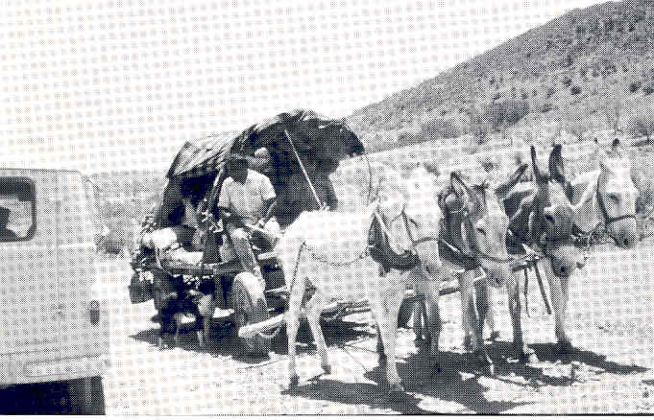
Aboriginal people gained access to newly introduced transport ideas as they became available so there are stories about seeing horses, donkeys, camels, bicycles and motor vehicles for the first time. Some Aboriginal people used carts or motor vehicles without engines and connected these to a camel or team of donkeys. There are photographs of such vehicles in The Adnyamathanha people: Aboriginal people of the northern Flinders Ranges, DECS 1992.

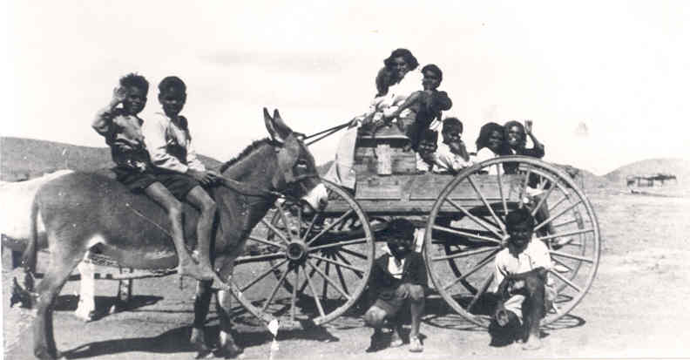
Above: Late 1960s Lachlan Wilton driving the donkey cart which traveled from Nepabunna to Copley occasionally – a trip which took two days each way requiring the travelers to camp overnight. David Tassell collection.

Right:1940s Yura yakartis (Adnyamathanha children from the Flinders Ranges) with donkeys and cart. Molly Wilton collection.

Aboriginal people and transport before European contact

Water transport

Aboriginal Technology: Watercraft by Alex Barlow, Macmillan Education 1994 is a picture book with text suitable for primary years covering a range of Aboriginal watercraft.

Aboriginal Bark Canoes of the Murray Valley by R Edwards, Rigby 1972 is an interesting book which might be in school libraries or available through interlibrary loan.

Hollowed out log canoes were used in parts of northern Australia.

Mangrove trunk rafts The following information is from Astronomy and Australian Indigenous people by Adele Pring from information supplied by Jeff Gillham, 1997.

The Bardi people living at One Arm Point on the tip of the Dampier Peninsula north of Broome in the Kimberleys, Western Australia, use their extensive knowledge of the moon and tides to time activities such as the collection of valuable trochus shells and other fishing pursuits.

Spring tidal movement can be up to ten metres so it is extremely important to be aware of them. Older members of the community have talked about using the stars to navigate when travelling by boats made from mangrove trunks. The boats are made from two layers of mangrove trunks stuck together by pegs. Parts of the boats, at least, often sat below water.

Navigational expertise was used in concert with knowledge of the tides since tides moved so rapidly at times, there is no way they could be paddled against.

The community assume that everyone has (and only outsiders don't have) a mental map of the area they move in thus directions consist for example of two bends/ two hills away."

Walking

Think about life before cars and before animals which could be ridden.

Apart from watercraft, there was no way to get around other than to walk or be carried. This would affect the amount of things one would choose to carry.

If you had to leave your home (eg as a refugee or just to go camping) and had to walk, what would you take with you?

Traditionally Aboriginal people carried as little as possible and chose implements which were multi-purpose. In many parts of Australia, Aboriginal people would revisit favourite campsites of previous years. Left behind at these campsites would be items too heavy to carry, such as large grinding stones, so each campsite would have these readily available. Each campsite would be close to water so that it didn’t need to be carried far.

Transporting items on the head

Pitjantjatjara women still make manguri, ring shaped cushions of handspun human hair to wear on the head to cushion a load such as a big wooden dish. There is a picture on p. 81 in the book Desert crafts.

Men sometimes carried on their heads kangaroo they'd hunted, when returning to camp. They would first tie parts together to make this easier. Moulded cakes of ochre could also be carried on the head to be traded.

Babies were sometimes transported in a pouch in the back of a possum skin cloak. There is a photograph of this on the cover of Conquest of the Ngarrindjeri and on p. 20 in the book The Aborigines by RM Gibbs, Longman Cheshire). Women generally didn't have more than one child under about 5 years old because of the transport difficulties when traveling long distances on foot.

Where main roads are located around Australia today is often where traditional paths were located. Students could think about why this might be.

The book Before the invasion: Aboriginal life to 1788, by Colin Bourke, Colin Johnson and Isobel White, Oxford University Press 1981 includes text and pictures to illustrate traditional Aboriginal life generally and transport with examples such as p 18 carrying containers, p 24 dugout canoe, p 40 water containers, p 42 log raft, p 43 outrigger canoes, p 44 rafts, p 56 baby in carrying dish,

The Aborigines by RM Gibbs, Longman Cheshire 1986 is not generally recommended because of the inappropriateness of some content but it’s good for some purposes. P 7 has an illustration of a mangrove log raft, p 12 has a Tasmanian canoe illustration, p 20 has a Ngarrindjeri woman with child on her back in her cloak, p 23 has containers for carrying water including a possum skin, skull and a shell, p 29 has two men carrying kangaroos lashed onto a spear they use as a bearer, p 42 has a bark canoe pic.

The Encyclopaedia of Aboriginal Australia, Volumes 1 and 2, by David Horton, Australian Institute of Aboriginal and Torres Strait Islander Studies, Canberra 1994 (books and CD Rom), includes useful references to transport items mentioned above.

