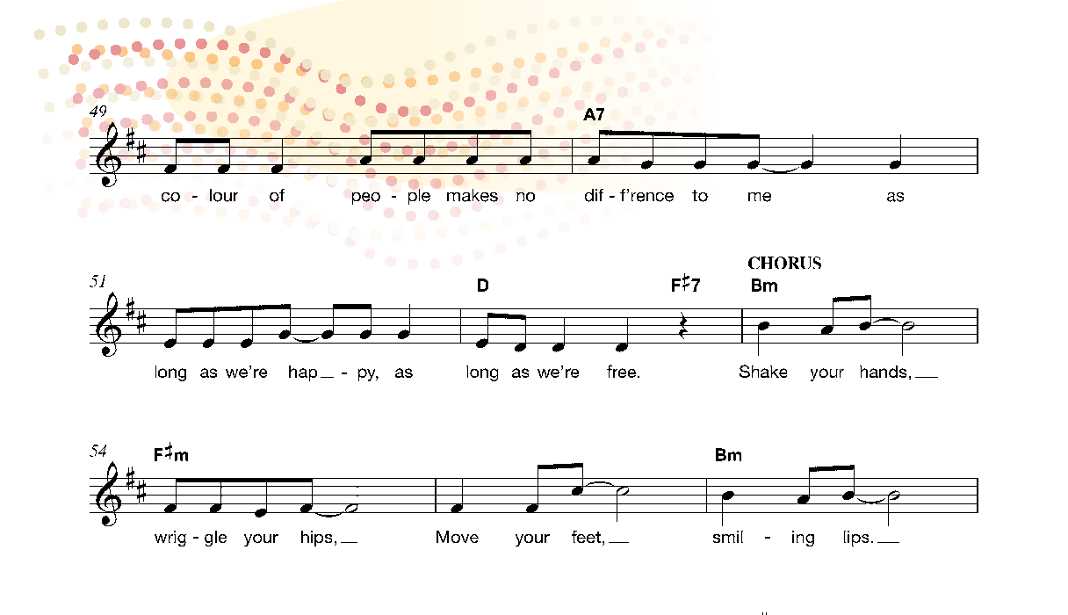
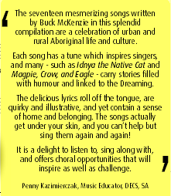
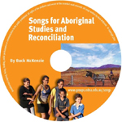
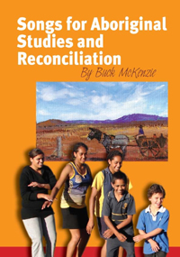
Songs for Aboriginal Studies and Reconciliation

A CD and songbook that has lyrics, teaching ideas, guitar chords as well as ideas for learning in all Australian Curriculum Arts subjects, History, English, Civics and Citizenship.

Post or email this order form with cheque, money order, or direct payment details to

HASS SA
(Humanities and Social Sciences)
PO Box 54, Prospect Hill SA 5201
www.hass-sa.asn.au/resources Email: sasose@adam.com.au
ABN 68 681 600 551

Date of order / / Purchaser’s order no (if relevant) so school can be invoiced.

Please supply copy/copies at $35 each, $30 each for 2 or more copies (postage included). No GST charged.

Name (please print clearly)
Postal address
Uni student special
$15 special discount for orders from university students.
Postcode
Tel: Email

Direct payments can be made to HASS SA
Bank SA 105 147 552528640 (please include your name)

OR pay by cheque or money order

For more information:
Please complete this form by typing in grey boxes, save, then go to
File > Send to >
Mail Recipient (as attachment)
sasose@activ8.net.au .
Otherwise please post.

Email sasose@adam.com.au

Download backing tracks and resources that link this resource
with Australian Curriculum at www.hass-sa.asn.au/resources

Form updated May 2018

